Inhalt

Title Page 2

Story and short Gameplay Introduction 3

Interface and Startup 4

Screen 1 – Profile Selection 4

Screen 2 – Match Finder 5

Screen 3 – Lobby 5

Game World 6

Character(s) and Controls 7

Main Gameplay Concept 8

Power-ups 9

Optional Features 10

# Title Page

* 1 Seite

# Story and short Gameplay Introduction

* ½ - 1 Seite

# Interface and Startup

This chapter provides information about the starting process of the game and some of the concepts behind. It contains the navigation screens the player must navigate through before the game starts.

The flow chart looks as follows:

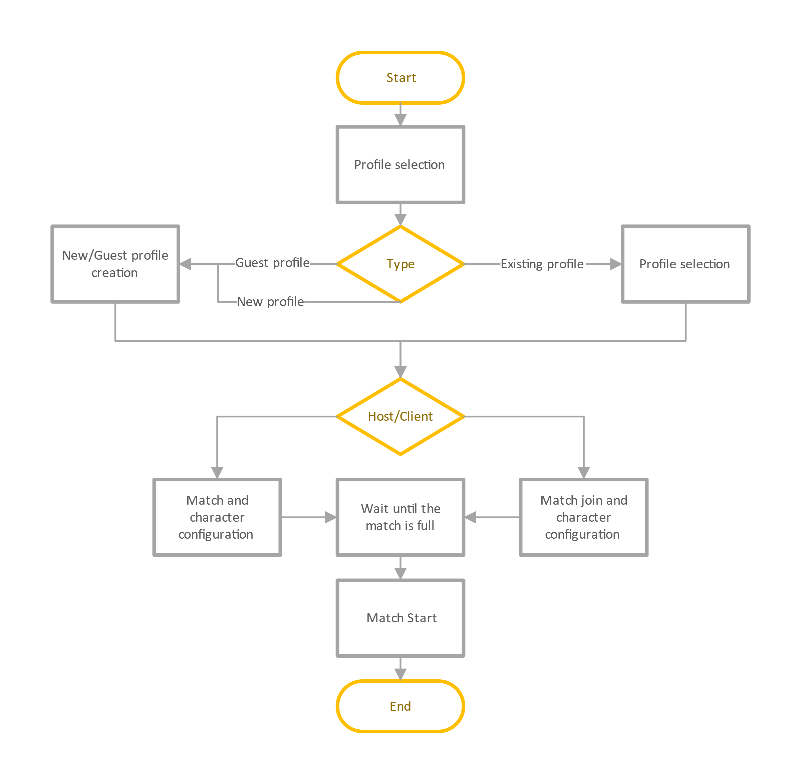

## Screen 1 – Profile Selection

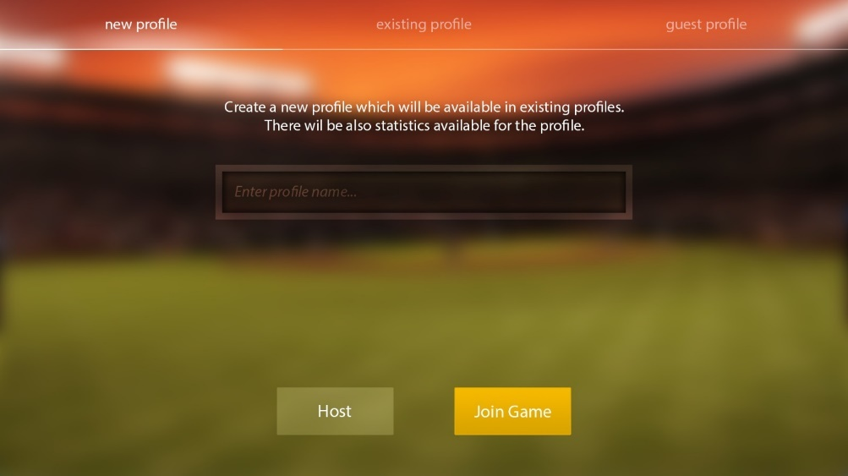When starting a game instance, the user must select a profile. The first screen loads all the local player profiles and displays them in a nice view with more information about statistic values from the past such as the number of won/lost matches. Since this game is a multiplayer within the local area network and without a server, the profiles cannot be stored on a server and are different on each device. Profiles are identified by username. The user has the possibility to create a new profile or to delete old profiles. After the profile selection the user must decide whether he wants to join or host a game. Depending on this decision he will be forwarded to the next screen.

## Screen 2 – Match Finder

If the user decided to join a game, he will be forwarded to the match finding screen. It displays a list of open matches in the local area network. Each entry in the list displays information about the host and the match including the hosts player name, his IP address and the number of free slots in the match. A refresh button enables the user to update the results list and to find newly created matches. If he is not able to find the match he is looking for, he can enter the hosts IP address directly in an edit box and join this way. After the match selection the player will be forwarded to the match lobby.

## Screen 3 – Lobby

If the user decided to be the host or he selected an existing match, he will be forwarded to the lobby screen. It contains an area for each of the four players. Every player can change his own robot character and must hit a button when he is ready. The screen will remain opened until the match is full, and every player is ready. In addition, the host can configure the teams and sees his own IP address for sharing in the LAN. 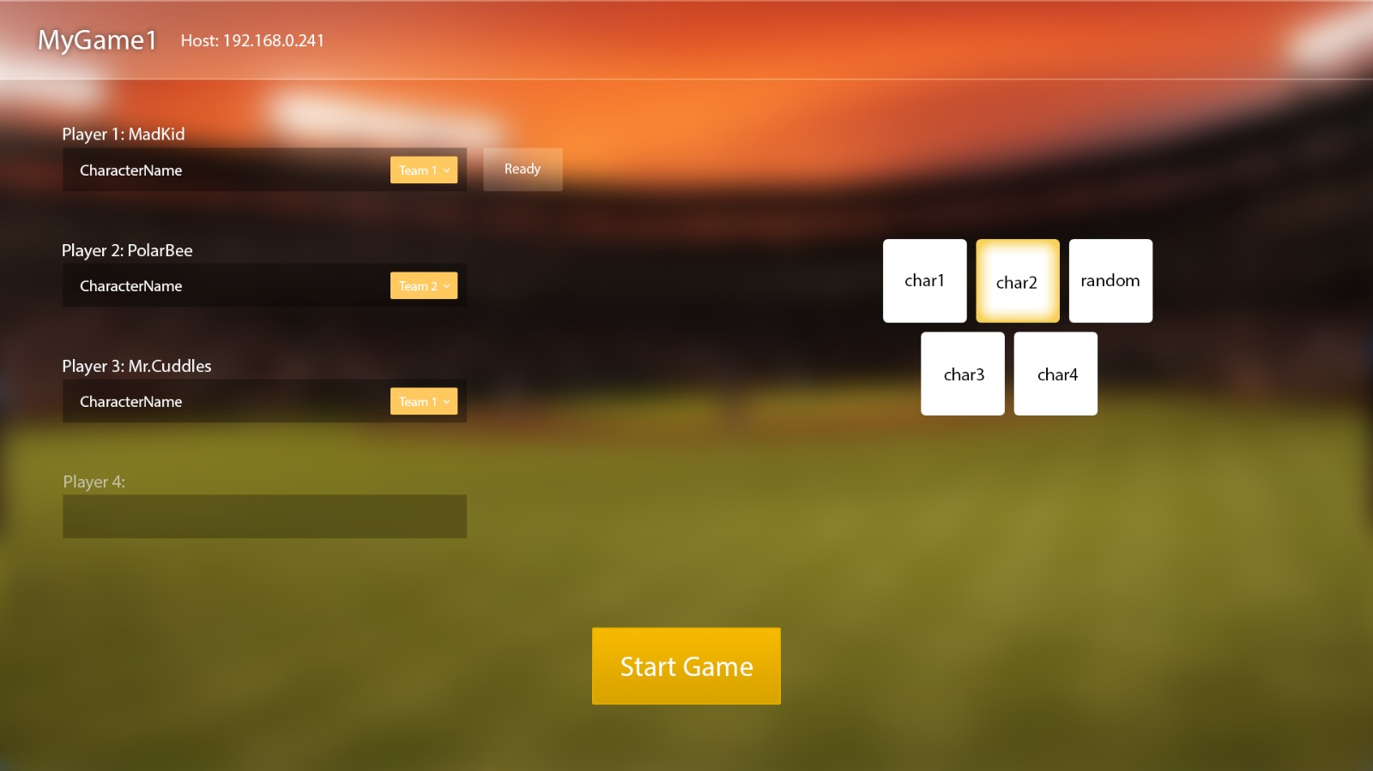

# Game World

* 1 - 2 Seiten

# Character(s) and Controls

* Charaktere und deren Hintergrund
* (Skizzen)
* Fähigkeiten
* Steuerung (rein funktional)
* Ca. 2 Seiten

# Main Gameplay Concept

* Überblick
* Spielablauf, Mechaniken
* Ca. 1 Seite

# Power-ups

* Überblick
* Wie erhalte ich Powerups
* Welche Powerups gibt es (Skizzen der Powerups)
* 1 – 2 Seiten

# Optional Features

For the first release we decided to provide only one pvp mode where players can play against each other with different team sizes.

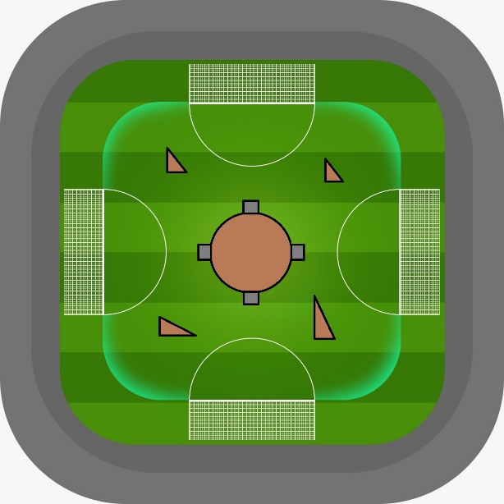  
For the future we are thinking about pve content. That could lead to large canon towers and other obstacles that must be destroyed for victory. This mode could be some kind of survival, because the canon tower would be able to shoot balls inside the goals, too. The center would not be limited to a canon tower. There could also be other enemies.

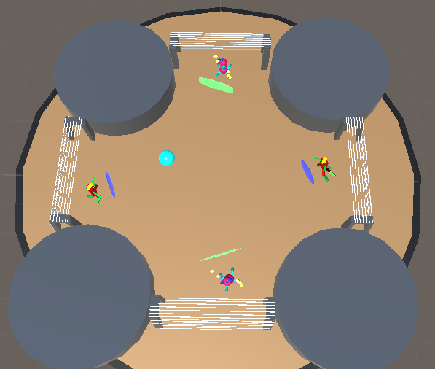Another changeable aspect is the gravity. There could be modes with very low or high gravity which would lead to a different behavior of the flying balls.

We are also thinking about to provide various arenas. The difference could be the location of the arena like wide desert, fire or ice landscapes that fit into the robot story. Furthermore the are possibilities to provide differently shaped arenas. For example with a hollow in the center or a completely rounded border.

We must remark that these optional features are only ideas at the moment and open for discussion. The implementation depends on feedback and the speed of the development process.